ICT PROJECT 1 – ASSESSMENT TASK 1

A1 DOCUMENT

**Team Number: 04**

1. **Musharraf Saeed (13131723)**
2. **Bhavishaben Patel (13196612)**
3. **MohitKumar Nayak (13152463)**
4. **Ranjeet kaur (13152904)**

**Lecturer name: Laura Antochi**

Table of Contents

1.1) Individual contribution for making this Documentation: 3

2.3.2) Milestone 2 (Due on 10th week): (A2) 4

2.3.3) Milestone 3 (Implement on SP22): Beta Release: 4

2.3.4) Milestone 4 (Due on 10th week SP22): 5

2.3.5) Time Line for only Alpha Release: 5

2.4) User Stories: 5

2.4.1) Priorities: 6

2.5) Project Client agreement: 8

2.6) Configuration management: 12

2.7) Programming languages: 12

2.9) Home page Demo Design: 13

3) References: 14

1) Team Description:

In our team there are 4 members. We are going to develop website which is about “seafood Take away” and our client name is Ruth Gomes. We are very about creating this website and show our practical skills and Knowledge through this project. At this point our team knows what our client need and what we have to develop. So we divide task for developing website to our group member.

# 1.1) Individual contribution for making this Documentation:

**Musharraf Saeed: (13131723)**

* Complete Agreement
* Prototype and Excel sheet with other team members
* Describe project and goals and arrange meeting with client.

**Bhavishaben Patel :( 13196612)**

* Milestones calculations
* Deliverables
* Help in prototypes
* Scope of alpha release and final release.

**Mohit Kumar Nayak :( 13152463)**

* Development tools
* Describe Programming Languages
* Help in Prototypes with team members.

**Ritu Sandhu :( 13152904)**

* Tell about User stories
* Help in Excel sheet and Prototypes with team member.

**2.0)** Justification for the project:

After a deep research in some ICT projects and online websites in conclusion due to online websites any organization get more fame and more customers and there sales and popularity increase because in this way customer easily get all the information about all available products and also put order online and if product is faulty or if there is any complain customer can give feedback.

**2.1)** Project description and goals:

It’s a Seafood Take away shop which is located in boronia Heights which provides seafood and some other fast food products to the customers with best quality and the owner of seafood want to increase their business by advertising and wants to introduce online order booking to safe the customer timings. Also customer can get discount and know about all the available and upcoming products information products. In this way customer can easily get all the information about shop any time.

Finally our main aim is to provide and satisfy all need which our client wants and produce best result for them.

**2.2)** Deliverable:

We have to deliver online working website as well as coding, Data base and all the paper works.

**2.3)** Milestones with Timeline:

In this all the activities we want complete in time and our team completing all the tasks on timeframe. In this activity we decide fulfill all the requirements of our client want and design based on priorities level and all things we apply based on our project secludes

**2.3.1)** Milestone 1 (Due before 6 week): (A1)

On this Milestone we get research about our project and decide our home page look, but we did not put any coding for home page. After that we show all this research to our client and get agreement for this project design. Also design timeline and days based priorities level.

### 2.3.2) Milestone 2 (Due on 10th week): (A2)

This week based on our study calendar for this trimester. During this time we have to implement our half part of our project (alpha release) on local server or domain address for test or check website.

### 2.3.3) Milestone 3 (Implement on SP22): Beta Release:

In this time period our client provides domain address and hosting.

### 2.3.4) Milestone 4 (Due on 10th week SP22):

Beta release:

In this we test our website and try to solve all problem and bugs which come during testing and these things have to complete in final week of our next trimester during SP22 study period.

In this release we have to give important to time and make sure about client requirement which is our priorities and give website to our client on the date which we promised.

### 2.3.5) Time Line for only Alpha Release:

Project Duration: = 9 weeks

Total Team Members: = 4

Working Days for project per week: = 2days

Total calculation of days for all team members: = 9 x 4 x 2 = 72days

**Timeline (For ICT1 & ICT2):**

Project Duration: = 14 weeks

Total Team Members: = 4

Working Days for project per week: = 2days

Total calculation of days for all team members: = 14 x 4 x 2 = 112days

## 2.4) User Stories:

**Home:**

*Description:* Short description about all the products, notification related to all products and events. It should be well developed and user attractive.

**Menu:**

*Description:* A drop down menu including different items with different varieties available at shop.

**Special Deals:**

*Description:* There should be detail information about available different special deals, product, their prices, and option for select any deals and calculator which shows amount of selected product and online booking options.

**Registration:**

*Description:* Registration form for the customers if they want to be member. Form require name, email, password, address and contact number of the customer.

**Login/Sign up:**

*Description:* Member can directly login and get discount, notification about our latest deals and promotion via text message or email.

**Contact Us:**

*Description:* Detail information about the shop address, contact number and timing that is opening and closing time of the shop.

**Feedback:**

*Description:* It is use for getting customer's review via social media and through our website.

**Search:**

*Description:* To look up for a particular item available in the entire menu.

### 2.4.1) Priorities:

In following chart, we have three columns Title, My Estimate and Priorities.

|  |  |  |
| --- | --- | --- |
| *Titles* | *My Estimate* | *Priorities* |
| Home | 5 Days | 10 |
| Menu | 2 Days | 50 |
| Special Deals | 4 Days | 10 |
| Registration | 4 Days | 20 |
| Login/Sign Up | 2 Days | 20 |
| Contact Us | 2 Days | 50 |
| Feedback | 4 Days | 10 |
| Search | 3 Days | 30 |
| Total | 31 days |  |

## 2.5) Project Client agreement:

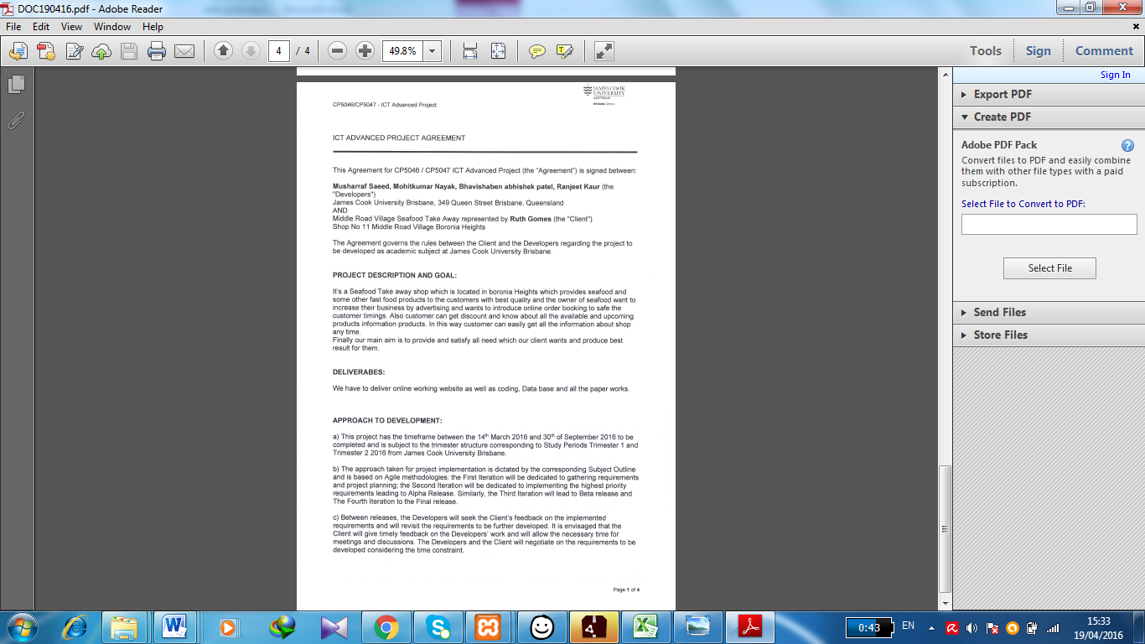

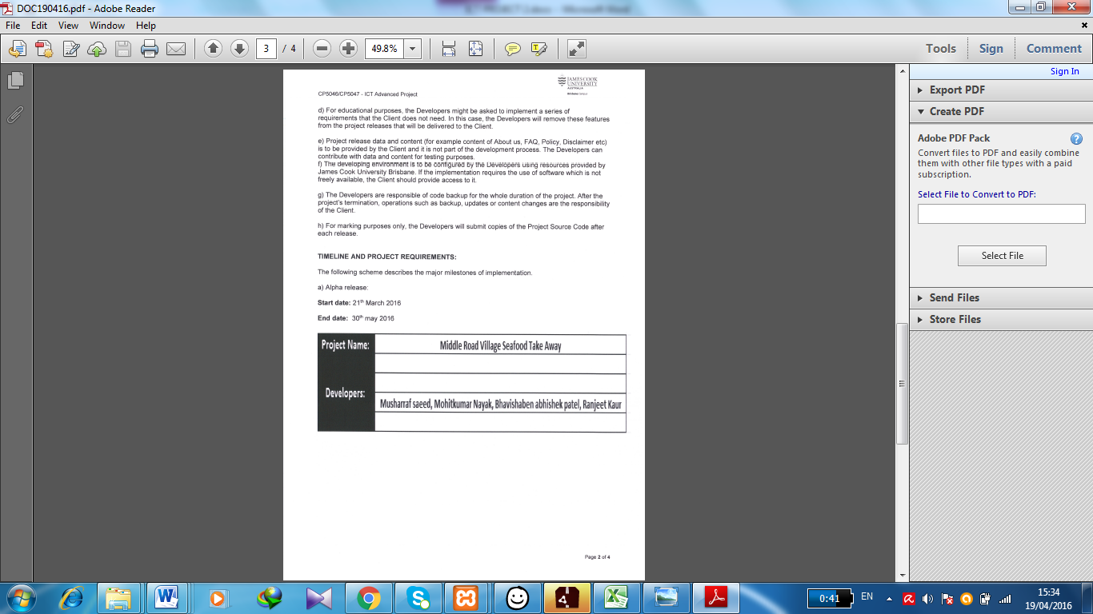

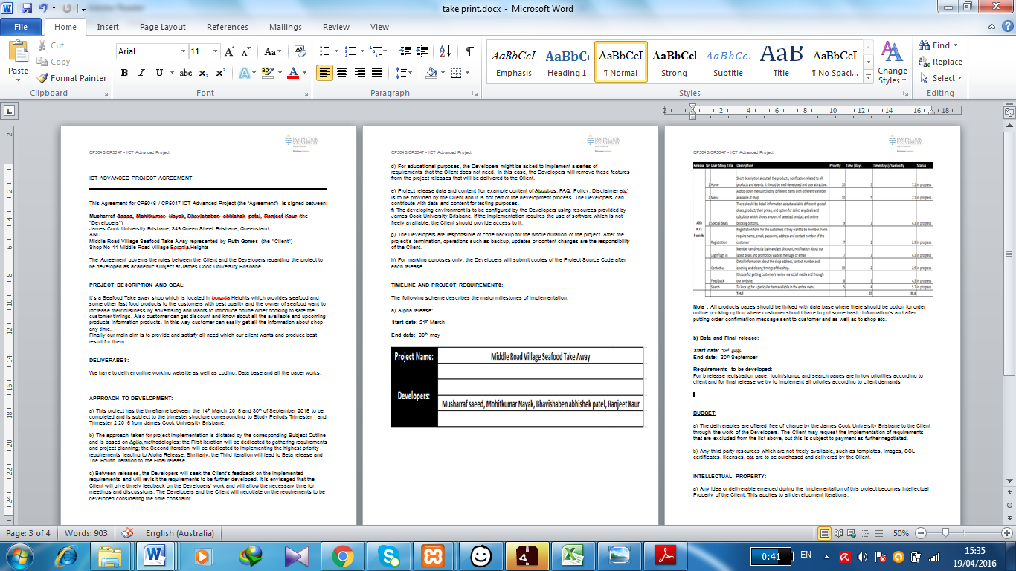

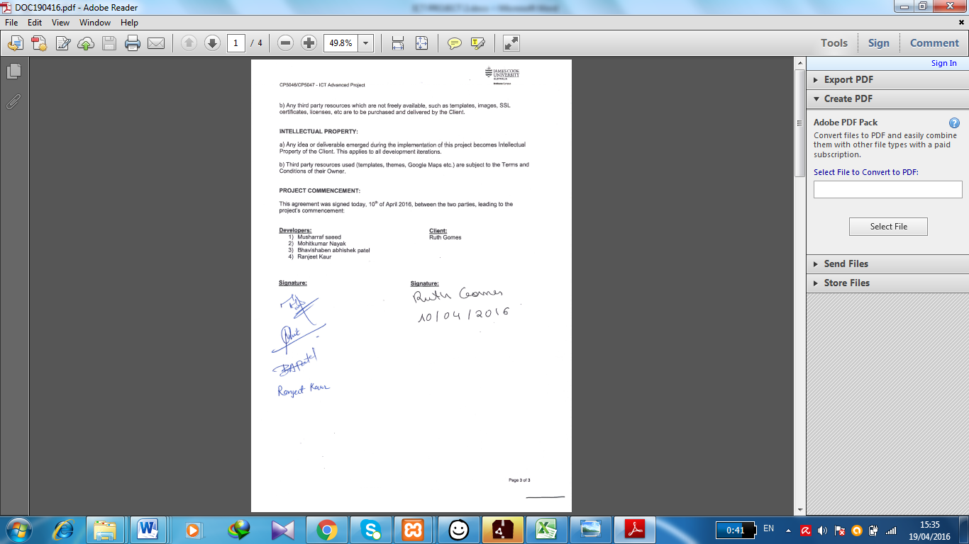

## 2.6) Configuration management:

**Github:**

To understand github we need to know about git. It is open source version control framework found in 2008 by Linus Trovalds who find Linux. We are going to use github in our project for share files make by group members. We are using repository it’s a location where we can store all our files. As it is version control system we can share any type of file in thatIt also provides collaboration features, like wikis and some task management tool for our project. (TC, n.d.)

**Development tool:**

**Word press:**

Word Press is an open source, online site creation tool which written in PHP. It is very easy to use and has very useful blogging system. There are many types of plugins and themes which we can use in our project. It is open source tool so we can use it to modify, redistribute and build our website. (Staff, n.d.)

## 2.7) Programming languages:

**HTML:**

HTML (Hypertext Markup Language) is the set of markup images or codes inserted in a document proposed for presentation on a World Wide Web program page. This language advises the Web program how to show a Web page's words and pictures for the client. Every markup code is linked to as a component. A few components come in sets that demonstrate when some showcase impact is to start and when it is to end. HTML5 was created to solve the problems which are affecting in HTML4. HTML5 runs flash pugins by itself. (Rouse, tech target, n.d.)

**PHP (HYPERTEXT PREPROSESSOR):**

PHP is a script language and interpreter that we can use it free. It is use for personal home page tools and use primarily on Linux web server. (Rouse, tech target, n.d.)

**CSS:**

It is a programming language in which we can use it for style, size and table for website. (Rouse, techtarget, n.d.)

**JAVA/JAVASCRIPT:**

Java is programming language designed to create complete applications that may run on a single computer and also be used to create applications or applet for web page. (Rouse, n.d.)

**2.8) Project Tools:**

In this project we use some tool for connecting team member and our work as well.

**Student Blackboard & JCU Mail:**

Blackboard & JCU Mail Provide exchange files and tools between team members which are provided by JCU. It is very good and important for project

**Drop box:**

This tool we use to send all files whether it is text, video and image.

**Development Tools:**

**XAMPP:**

This tool we can use without internet and check our work. It can be used with any operating system.

**Dreamweaver:**

We can do some coding using this tool and it is very good tool for beginner.

**Testing: Local Server:**

After completing design part programmer want to test their project on local server or domain which may be provide by their client.

## 2.9) Home page Demo Design:

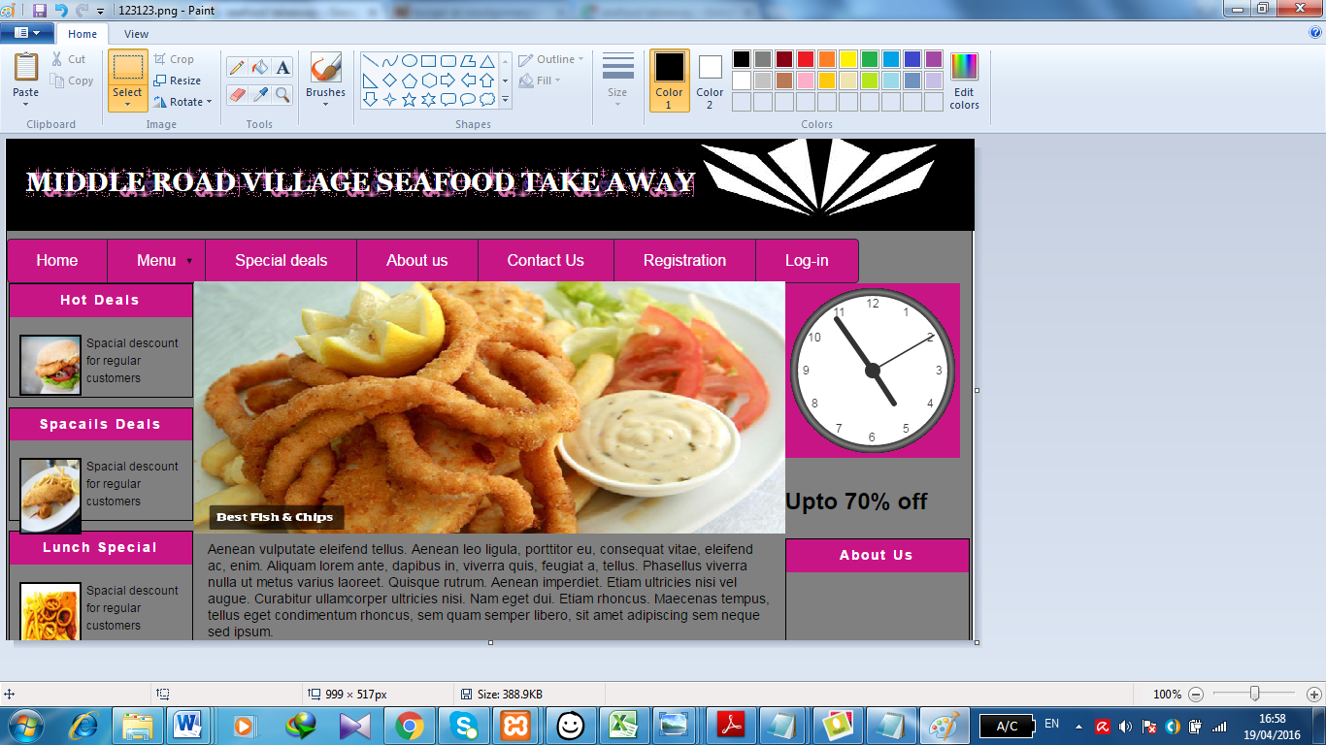

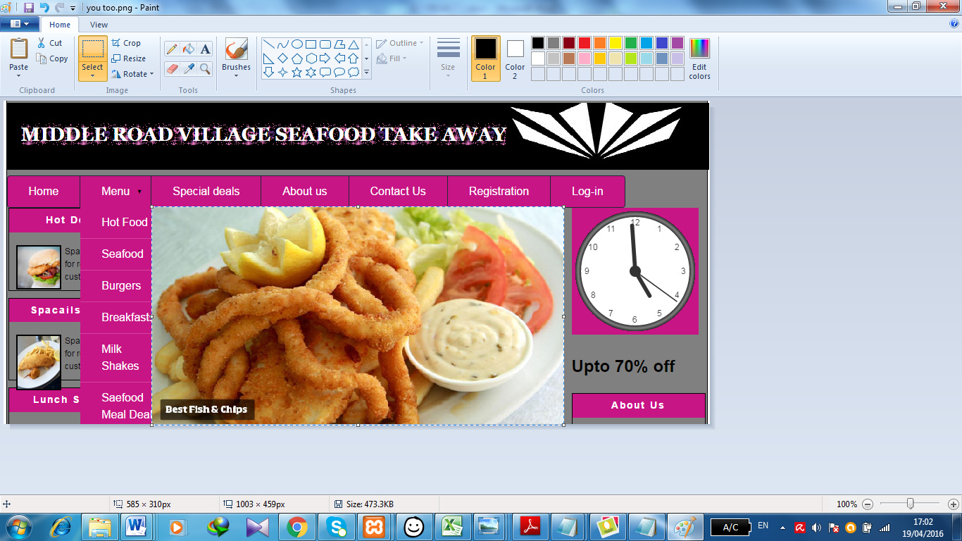

# 3) References:

Bibliography

Rouse, M. (n.d.). Retrieved from tech target: http://searchsoa.techtarget.com/definition/Java

Rouse, M. (n.d.). *tech target*. Retrieved from http://searchenterpriselinux.techtarget.com/definition/PHP

Rouse, M. (n.d.). *tech target*. Retrieved from http://searchsoa.techtarget.com/definition/HTML5

Rouse, M. (n.d.). *techtarget*. Retrieved from http://searchsoa.techtarget.com/definition/cascading-style-sheet-CSS

Staff, E. (n.d.). *wpbigginer*. Retrieved from http://www.wpbeginner.com/beginners-guide/why-is-wordpress-free-what-are-the-costs-what-is-the-catch/

*TC*. (n.d.). Retrieved from http://techcrunch.com/2012/07/14/what-exactly-is-github-anyway/